ASSIGNMENT 3:
1.
Create a new S3 bucket named 'my-zomato-images' and upload at least 3 sample image files representing restaurant menu items.
ANS : Screenshot 1 — Bucket creation
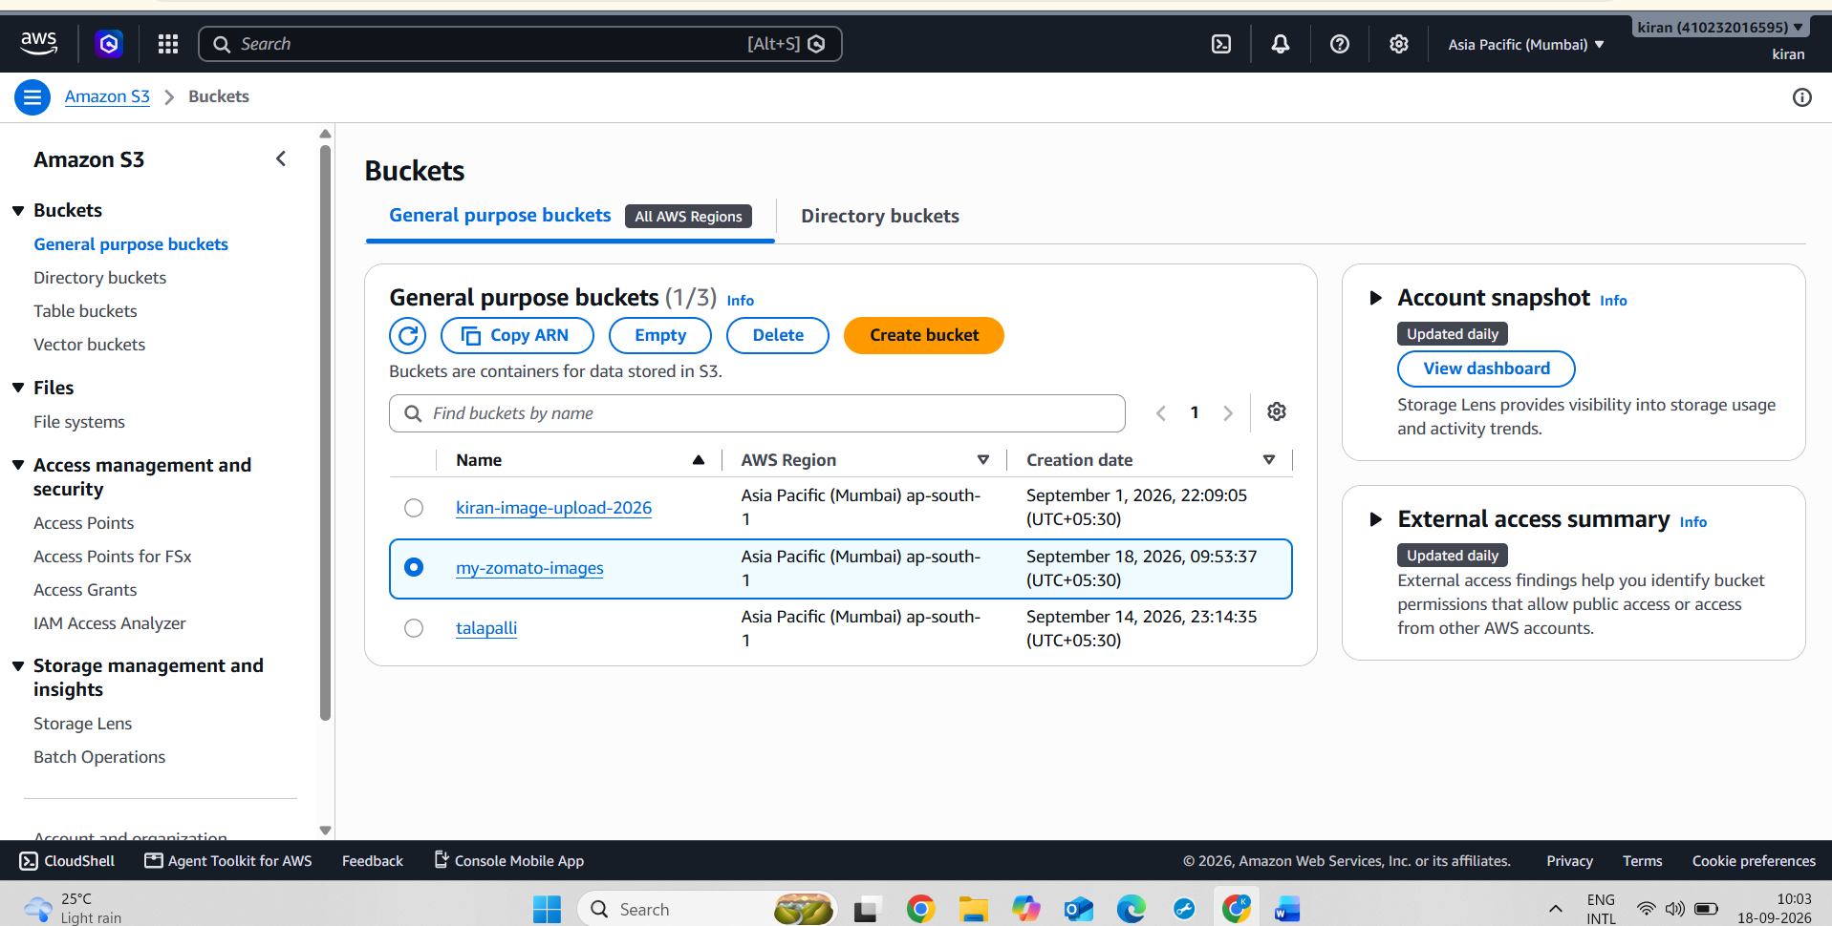
Screenshot 2 — Uploaded images:
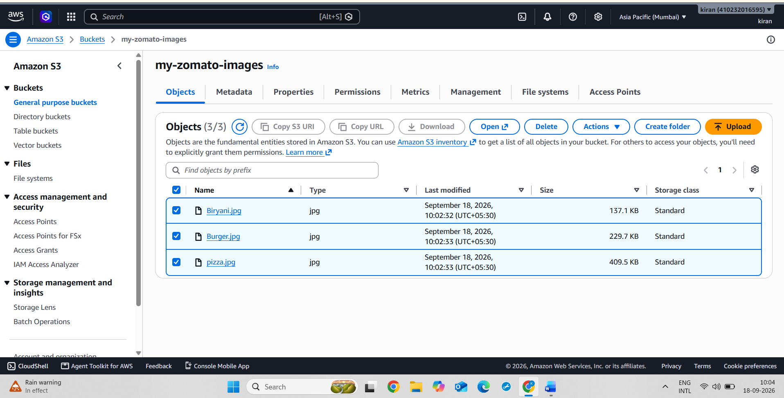

2.
Set up a lifecycle policy on your 'my-zomato-images' S3 bucket to automatically transition all objects older than 30 days to the Glacier storage class.<br><br><em><strong>Hint:</strong> Use the S3 Management Console's 'Lifecycle rules' section to define the transition action.</em>
ANS : Screenshot : The Management → Lifecycle rules page showing the created rule.
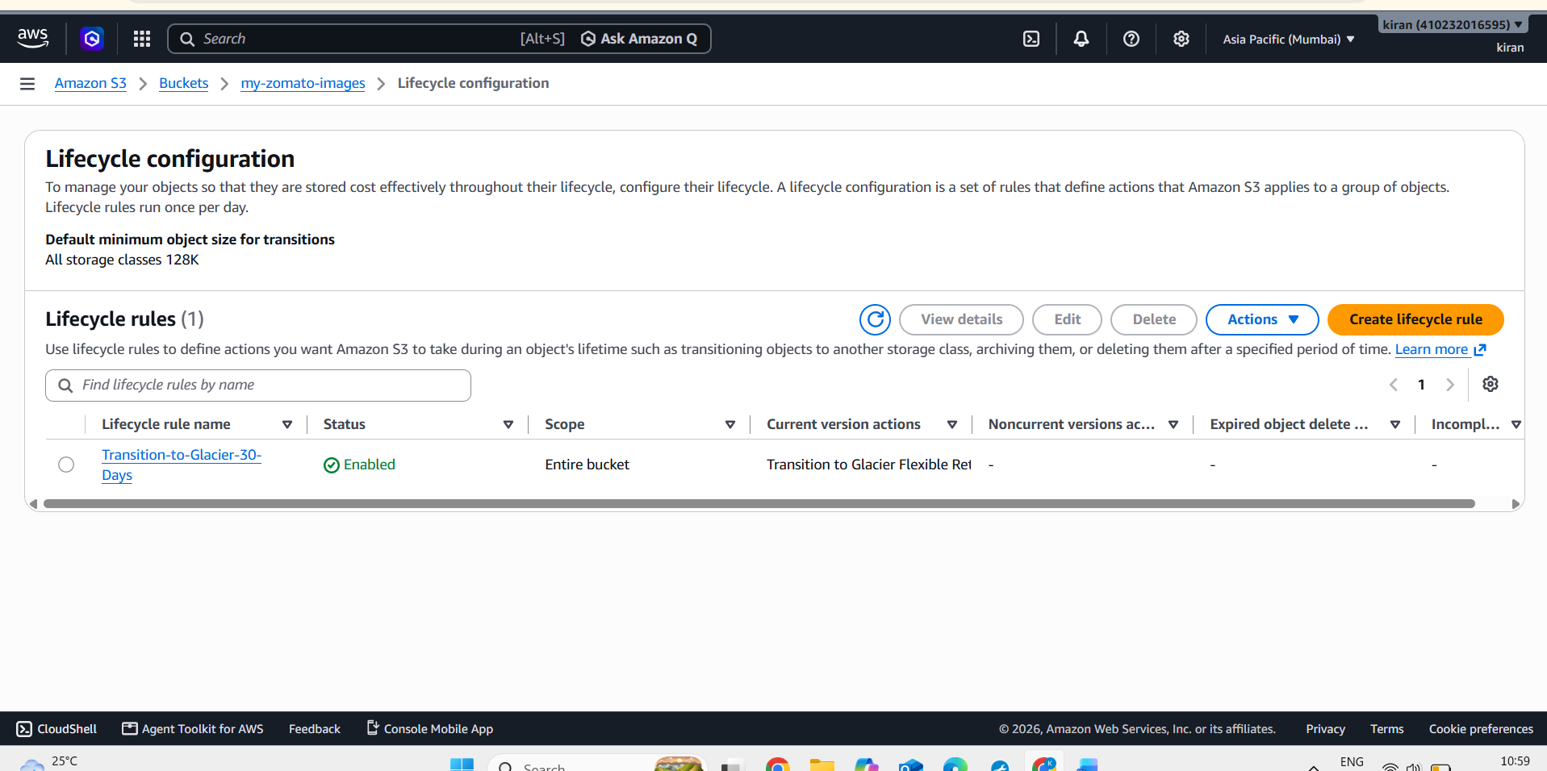
Screenshot :The lifecycle rule configuration showing
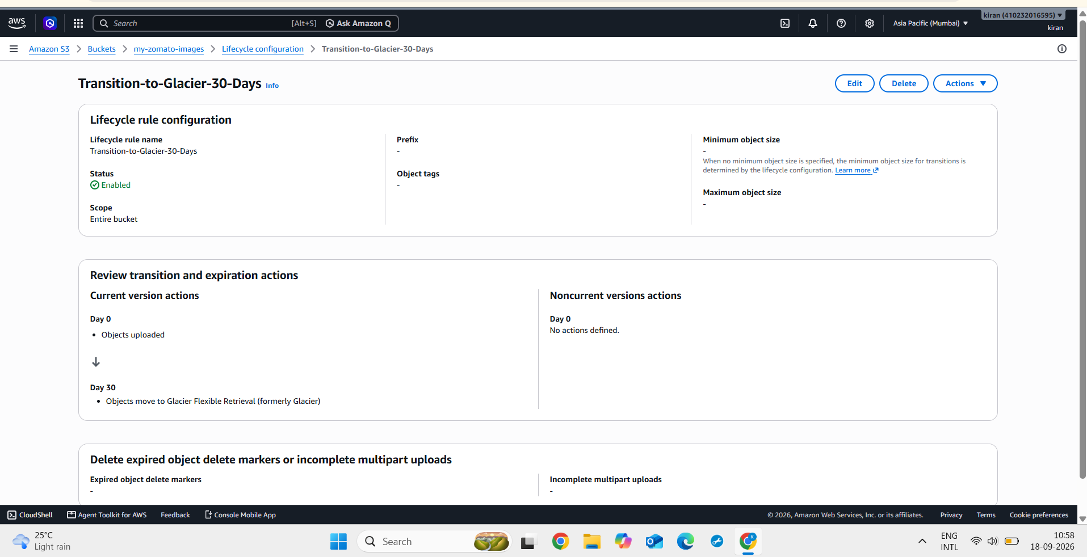
3.
Simulate a cost optimization scenario: calculate and compare the estimated monthly storage cost for keeping 5GB of images in S3 Standard versus S3 Glacier using AWS Pricing Calculator.<br><br><em><strong>Hint:</strong> Use the AWS Pricing Calculator website and note down the difference in INR.</em>
ANS : Screenshot 1 : S3 standard
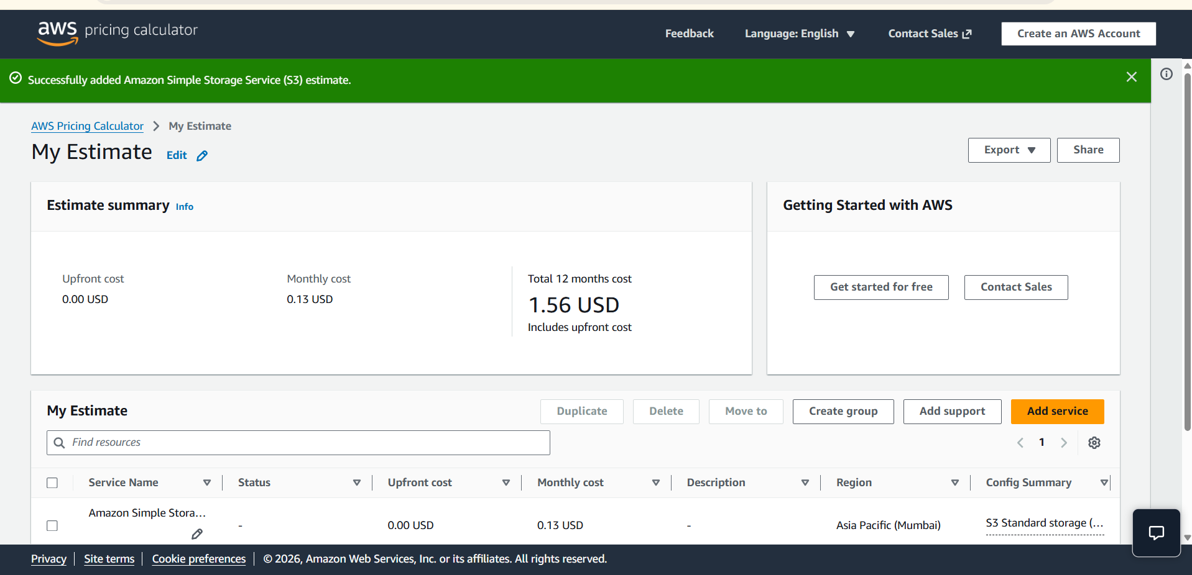
Screenshot 2 : Glacier Flexible Retrieval
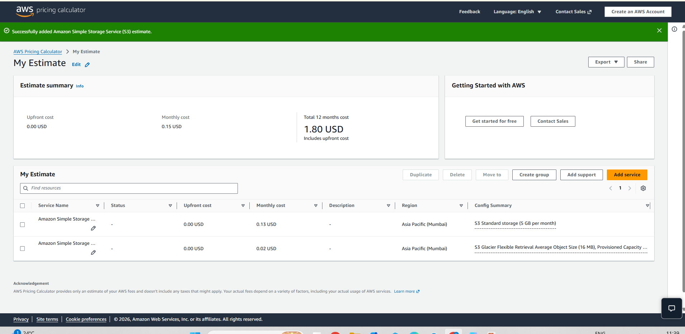
4.
Add a new rule to your S3 bucket's lifecycle policy so that any objects with the prefix 'offers/' (e.g., 'offers/summer2024.jpg') are deleted automatically after 60 days.
ANS :
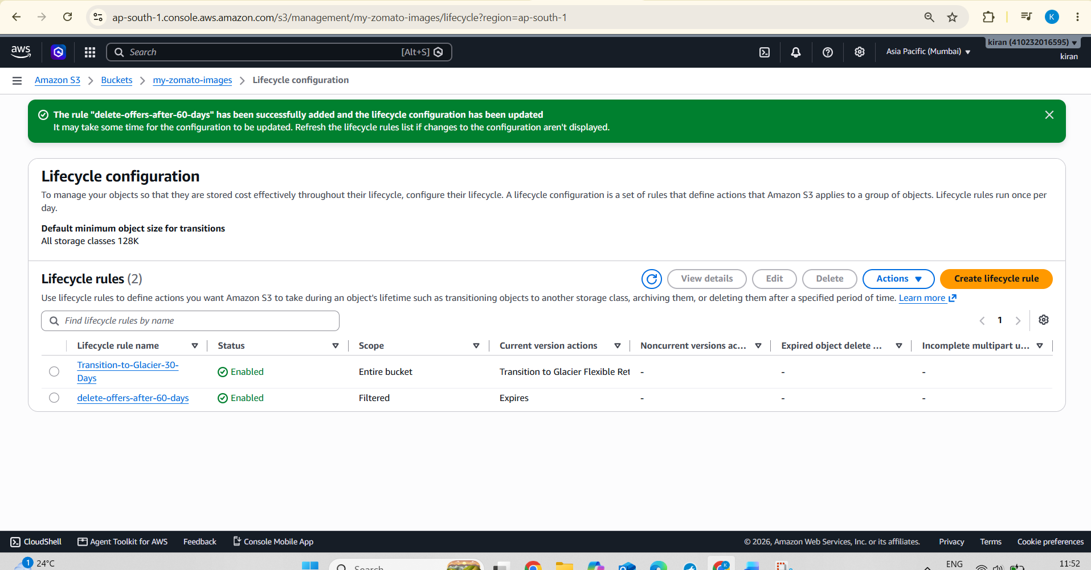
5.
Use ChatGPT to generate a sample JSON configuration for an S3 lifecycle policy that transitions files to Glacier after 15 days and deletes them after 180 days. Paste the generated JSON and briefly explain each section.
ANS :
Sample Json Configuration for S3 Lifecycle Policy
{
"Rules": [
{
"ID": "MoveToGlacierAndDelete",
"Filter": {
"Prefix": "offers/"
},
"Status": "Enabled",
"Transitions": [
{
"Days": 15,
"StorageClass": "GLACIER"
}
],
"Expiration": {
"Days": 180
}
}
]
}
Section | Explanation
Rules | Contains the lifecycle rule.
ID | Gives the lifecycle rule a name.
Filter | Defines which objects the rule applies to.
Prefix: "offers/" | Applies the rule to objects beginning with offers/, such as offers/summer2024.jpg.
Status: "Enabled" | Activates the lifecycle rule.
Transitions | Defines when an object moves to another storage class.
Days: 15 | Makes the object eligible for transition 15 days after creation.
StorageClass: "GLACIER" | Moves the object to S3 Glacier Flexible Retrieval.
Expiration | Defines when the object expires.
Days: 180 | Makes the object eligible for expiration 180 days after creation.

